|  |  |  |
| --- | --- | --- |
| **Roll No.** | **PRN Number** | **Name of Student** |
| B201 | 2146491245076 | Kunal Shalikrao Kanode |
| B202 | 2146491245078 | Abhishek Shivkumar Singh |
| B203 | 2146491245079 | Ritesh Pradip Upate |
| B204 | 2146491245080 | Tarang Dilip Andhare |
| B205 | 2146491245081 | Chinmay Sudesh Kulte |
| B206 | 2146491245082 | Ritesh Kishor Tapase |
| B207 | 2146491245083 | Chaitanya Ashish Rawat |
| B208 | 2146491245085 | Khushi Dhirendra Sahu |
| B209 | 2146491245086 | Ayush Pankaj Malani |
| B210 | 2146491245087 | Abhay Sunil Vyas |
| B211 | 2146491245089 | Namrata Ramdas Chaudhari |
| B212 | 2146491245090 | Dwij Vilasrao Naranje |
| B213 | 2146491245091 | Trushal Indalsing Dhumale |
| B214 | 2146491245092 | Prajwal Pravin Halde |
| B215 | 2146491245093 | Pranav Navalkishor Tiwari |
| B216 | 2146491245094 | Mohd Inshal Sheikh |
| B217 | 2146491245095 | Chandar Vinodrao Umaratkar |
| B218 | 2146491245096 | Gaurav Sandiprao Bobade |
| B219 | 2146491245097 | Harshal Maroti Mude |
| B220 | 2146491245098 | Atharva Ramesh Warade |
| B221 | 2146491245099 | Mrudula Ravindra Pangul |
| B222 | 2146491245100 | Avantika Praful Barudwale |
| B223 | 2146491245101 | Pranav Pathekar |
| B224 | 2146491245102 | Piyush Manoj Raut |
| B225 | 2146491245103 | Prerana Shrawan Borkar |
| B226 | 2146491245104 | Tanmay Vijay Mungelwar |
| B227 | 2146491245105 | Chhakuli Sanjayrao Gawande |
| B228 | 2146491245106 | Sharayu Surendrasingh Kakas |
| B229 | 2146491245107 | Farhan Athar Khan |
| B230 | 2146491245108 | Himanshi Shailesh Dave |
| B231 | 2146491245109 | Nikita Ajay Bhoyar |
| B232 | 2146491245110 | Chanakshi Sandip Holkar |
| B233 | 2146491245111 | Harshada Pramod Chafle |
| B234 | 2146491245112 | Sanika Gajanan Bobhate |
| B235 | 2146491245113 | Nishigandha Pravin Ekapure |
| B236 | 2146491245114 | Jivak Ajay Wankhede |
| B237 | 2146491245115 | Sauryansh Vinay Shrivastav |
| B238 | 2146491245116 | Kiran Hanuman Wairagade |
| B239 | 2146491245117 | Aachal Abhay Nawade |
| B240 | 2146491245118 | Ninad Mahendra Lunge |
| B241 | 2146491245119 | Ritesh Rajesh Adwani |
| B242 | 2146491245120 | Avantika Kishor Patil |
| B243 | 2146491245121 | Saurabh Gajanan Shendurkar |
| B244 | 2146491245122 | Mansi Yogesh Sahu |
| B245 | 2146491245123 | Aachal Rajesh Shrivastav |
| B246 | 2146491245124 | Yashwardhan Padmakar Katkamwar |
| B247 | 2146491245125 | Chanchal Pradeep Sher |
| B248 | 2146491245126 | Khizar Mohmmad Mohmmad |
| B249 | 2146491245127 | Piyushi Nitin Labhe |
| B250 | 2146491245128 | Harsh Vinod Krishnani |
| B251 | 2146491245129 | Renuka Nandkishor Joshi |
| B252 | 2146491245130 | Nidhee Ramadhar Shukla |
| B253 | 2146491245131 | Anshul Gautam Moon |
| B254 | 2146491245132 | Ninad Nitin Shinde |
| B255 | 2146491245133 | Vedant Sudhakar Hage |
| B256 | 2146491245134 | Rishikumar Ramanyan Shukla |
| B257 |  | Admission from other branch |
| B258 |  | DSY 1 |
| B259 |  | DSY 2 |
| B260 |  | DSY 3 |
| B261 |  | DSY 4 |
| B262 |  | DSY 5 |
| B263 |  | DSY 6 |
| B264 |  | DSY 7 |
| B265 |  | DSY 8 |
| B266 |  | DSY 9 |
| B267 |  | DSY 10 |
| B268 |  | DSY 11 |
| B269 |  | DSY 12 |

|  |
| --- |
| **Prof. Sheetal Kale**  **HoD, CE** |

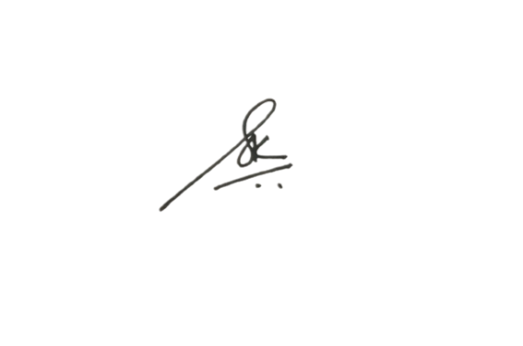

|  |
| --- |
| **Prof. Sheetal Kale**  **HoD, CE** |
| **Prof. Sheetal Kale**  **HoD, CE** |

|  |
| --- |
| **Prof. Sheetal Kale**  **HoD, CE** |